Economics and Hillel the Elder
ByMAAYAN HOFFMAN
Jerusalem Post, July 26, 2017

Assaf Razin became a world-renowned economist without losing sight of the centrality, humanity and needs of the individual.

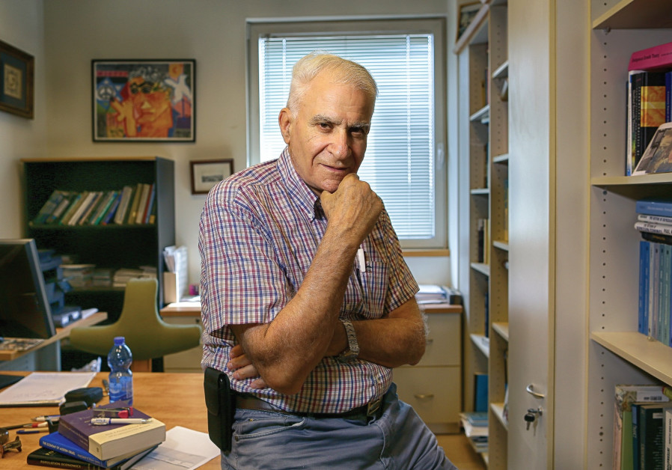
ASSAF RAZIN. (photo credit:Courtesy)
In 1924, the late English economist John Maynard Keynes deliberated on what makes a great economist: “The master-economist… must be mathematician, historian, statesman, philosopher – in some degree. He must understand symbols and speak in words. He must contemplate the particular in terms of the general and touch abstract and concrete in the same flight of thought. He must study the present in the light of the past for the purposes of the future.”
Keynes was eulogizing a colleague economist who died 17 years before Israeli economist Assaf Razin was born in 1941. But, if you ask colleagues and students, Keynes’s words could have been describing the ideal this 2017 EMET Prize winner for social sciences aspires to achieve.

The full article:
In 1924, the late English economist John Maynard Keynes deliberated on what makes a great economist: “The master-economist … must be mathematician, historian, statesman, philosopher—in some degree. He must understand symbols and speak in words. He must contemplate the particular in terms of the general and touch abstract and concrete in the same flight of thought. He must study the present in the light of the past for the purposes of the future.”

Keynes was eulogizing a colleague economist who passed 17 years before Israeli economist Assaf Razin was born in 1941. However, if you ask colleagues and students, Keynes' words could have been describing the ideal this 2017 EMET Prize winner for social sciences aspires to achieve.

Razin studied and shared ideas about globalization before many modern commentators on the subject even heard of the word, according to Prakash Loungani, an adviser at the International Monetary Fund. Migration and its impact on welfare states, economic policies that would have to shift in a world that is smaller and more accessible – “All the issues we are dealing with now, he was writing about all of it 20 or 30 years ago,” said Loungani.

Razin’s accomplishments are most surprising, considering his upbringing in Kibbutz Shamir in the Upper Galilee. He was born to a family of modest means with Marxist ideals. The professor describes his life as one of extremes – from the kibbutz to Tel Aviv University; from Israel to different parts of the world; and from his childhood in the nursery bed of socialism to the Economics Department at the University of Chicago, the cradle of intellectual capitalism, from where he received his Ph.D. in economics.

Despite some rather dramatic personal events, including the death of his son in 1996 at the age of 30, Razin’s academic and professional achievements are truly outstanding, said Lars E.O. Svensson, a professor in the Stockholm School of Economics.

“Assaf has an excellent standing in the international community of scholars,” said Svensson. “He is a most welcome visitor to universities, research institutes and international organizations all over the world, and he is a high appreciated participant in international conferences.”

Razin’s portfolio is likewise unusually diverse. He did work on human capital, fertility, and growth. His early book with Elhanan Helpman, “A Theory of International Trade under Uncertainty” (Academic Press 1978), was an eye-opener and brought a new and fruitful approach to understanding international trade. His work on exchange-rate regimes and a cash-in-advance approach to the demand for money, also with Helpman, inspired many. His work with Jacob Frenkel on fiscal policy, summarized in the book “Fiscal Policies and the World Economy (MIT Press 1987), has been very influential, as have several papers on international taxation. Later, his work on population, immigration, and welfare economics in several papers and books with Efraim Sadka received considerable attention.

“With Assaf, working hard gained a new meaning for me,” said Svensson. “My future work and career benefitted enormously from this experience.”

On a sunny, Tel Aviv afternoon, Razin spoke matter-of-factly about his life’s work, from his corner office on the top floor of the Eitan Berglas School of Economics at TAU. A black office chair, rows of books – mostly in English – a handful of pens, in different colors and sizes strewn across his desk, set the backdrop for a detailed discussion on economic policy.

“The European crisis is something that we international economists studied for decades,” Razin told The Post. “But while many economists look at migration as just a form of movement of inputs – labor – across borders, that’s not the way I see it. Migration is not just a movement of labor, it is movement of people,” said Razin, loosely quoting the Swiss playwright Max Frisch who recently quipped, “We wanted workers, but we got people instead.”

Grossly simplified, Razin argues that immigration of low-skilled workers, like we see in Europe, creates winners and losers. Low-skilled native workers are typically harmed by low-skilled immigrants, who compete for their jobs and depress their wages. Low-skilled immigrants are also more likely to be net
beneficiaries from a generous welfare state, the burden of which low-skilled workers share.

“Brexit, the United Kingdom's withdrawal from the European Union, was partly the result of an anti-immigration feeling in Europe,” said Razin.

But the impact of immigration on receiving countries depends on the conditions that motivated the exodus, on the immigrants, and on the conditions the immigrants encounter when they arrive in their new homes, said Razin. This coming December, Razin’s latest book, “Israel and the World Economy: Power of Globalization,” will be published. In it, he tells the story of the migration to Israel of people from the Former Soviet Union. Israel, Razin said, is unique, because it is the only country in the world that allows free migration.

“After the collapse of the Soviet Union, the Soviet Jews were free to choose to stay in Russia, go to America (despite its quotas) or Western Germany, or Canada, or Australia. But the majority came to Israel because there were no barriers to entry,” explained Razin. “This new 20 percent of the population led to a transformational change in Israel’s political-economic system.”

First, unlike the recent Mideast and African migrants, these were skilled immigrants who helped increase the productivity of the low-skilled population. And, likewise, they were two-earner families, meaning they had a tradition of both the mother and father working. This led to an increase in the wages of other high-skilled workers, and rather than imposing a financial burden on the welfare state, “they are, of course, the basis for the emergence of Israel as a startup nation.”

At the same time, Razin said, it did “move Israel as a welfare state a bit down – decreasing child welfare payments, lowering taxes on higher income groups, and things like that. We have a majority voting parliamentary system, so over time, these immigrants were able to impact government priorities.”

Razin likewise focuses on the challenge of high fertility and anemic skill acquisition, meaning that children born into large families often achieve less educationally and academically – also a concern for the State of Israel.

“Among OECD countries, Israel has the highest fertility rate. From an economic point of view, this is a concern,” Razin said.

If you look at Western populations, parents make rational and altruistic decisions about how many children they will have and how much they will be able to invest in the education of those children. But in some communities, including in the Israeli ultra-Orthodox community, it is not only the private incentives of parents that matter, but also social incentives or peer pressure. In other words, parents who cannot afford – from a time or financial perspective – to have so many children, may do so out of a feeling of social obligation. The solution is therefore very complicated, because you would have to change not an individual’s mentality, but the social behavior of an entire group of people.

“If a family has limited resources, then if you have larger families you can spend less per child. What can help change the equation of high fertility, less market-skill acquisition? A strong public education system,” said Razin. “Therefore, the core curriculum is essential in haredi public schools – and in all public schools, both here and in America.”

Razin can also talk about the need for regulation in the banking sector or why the government should be engaged in the healthcare system. His eyes light up when he speaks about his work.

“Economics is complicated,” Razin said, his finger outward. “People on the outside often don’t really appreciate it.”

For Razin, winning the 2017 EMET Prize represents a meaningful step in his life’s trajectory.

“Receiving the EMET Prize 76 years after being born in a Kibbutz is a nice endpoint for this traveler,” said Razin, though he has no intention of retiring.

Razin said he always tried to be a role model for his children and now grandchildren. He sees that each generation of his family has increased opportunities. He hopes the prize will influence their decisions about how they conduct themselves in life and work.

But he said he doesn’t live by economics or achievements. Rather, he lives by a statement made thousands of years ago by Hillel the Elder: “That which is undesirable to you, do not do to your fellow. This is the entire Torah. The rest is just commentary.”

“I talk about anti-migration and immigration, economic policies and all of that,” said Razin. “But the most important thing – I got it from my parents – is this statement by Hillel. When it comes to Arab-Israeli relations, black and white, refugees or whatever is going on in the world, no matter the economics, love your neighbor as yourself is my strongest view.”

